Review On Android: An ARM Based Operating System For Mobile Phone(Smartphone)

Mahizebin Shams-E-Mofiz, Mosabber Uddin Ahmed

Department of Electrical and Computer Engineering, North South University

Plot-15, Block-B, Bashundhara, Dhaka, Bangladesh

Email: mahizebin.shams@northsouth.edu, mosabber.ahmed@northsouth.edu

Abstract— Due to the technological development, mobile terminals have evolved into functionally sophisticated devices such as smartphones and tablets. The Android platform has become one of the most popular operating system with millions of new users each year. Android OS has broad and open source platform with four layers, commenced with the Android platform and the features of Android applications, gave a detailed picture of Android application framework from the potential of developers. The home screen of devices booted with android have primary navigation and information. These are in Android devices as to the desktop found on personal computers. If we illustrated with a simple music player as example to demonstrate the basic working processes of Android application components as it plays the music by using the service component as media player from class of libraries layers. Despite many studies, none have provided a comprehensive description of this operating system. In this paper we present a review of the Android Operating System. We describe the platforms history including improvements involved in each release as well as the systems architecture ,project structure, design principles of the operating system. I will present a detailed understanding of the technology used in process and memory management, its file systems, security used etc.

Index Terms— Android OS, Android Architecture layers, Android Application, Android Linux Kernel, Android Dalvik virtual machine, Android Application Component, Mobile computing, Operating systems, Software.

INTRODUCTION

Android operating system is one of the most widely used mobile Operating System these days [1]. Android mobile operating system is based on the Linux kernel and is developed by Google. Android operating system is primarily designed for smartphones and tablets. Since Android is an open source it has become the fastest growing mobile operating system. Due to its open nature it has become favorite for many consumers and developers. Moreover software developers can easily modify and add enhanced feature in it to meet the latest requirements of the mobile technology [2]. Android users download more than 1.5 billion applications and games from Google Play each month. Due to Its Powerful development framework users as well software developers are able to create their own applications for wide range of devices [3]. Some of the key features of Android operating system are: Application Frame work, Dalvik virtual machine, Integrated browser, Optimized Graphics, SQLite, Media Support, GSM
Technology, Bluetooth, Edge, 3G, Wi-Fi, Camera and GPS etc. [1]. To help the developers for better software development Android provides Android Software development kit (SDK). It provides Java programming Language for application development [1]. The Android software development kit includes a debugger, libraries, a handset emulator based on QEMU (Quick Emulator), documentation, sample code, and tutorials [4].

II.BACKGROUND & HISTORY

Android is described as a mobile operating system, initially developed by Android Inc. At present smart phone usage is increasing dramatically due to their extended functionality than cell phones. Smartphones are like small computer which accompany us everywhere and allow us to access various functionalities. Smart phone is a personnel device which provides entertainment, information, making call, writing SMS and accessing different applications like check the email, to browse the Internet or to play games with our friends. We have to install applications on our smartphone in order to take all the advantage that these devices offer. The increasing importance of smart phones has increased competition among technology giants to take over the bigger part of the market share for mobile platform. As a result, in 2005 Google introduced Android (developed by Andy Rubin the Director of Mobile Platforms for Google), an open source mobile platform for smart phone devices which is consisting of a Linux Kernel, runtime environment, development framework, libraries and key applications. This paper aims to deal with the comparison between different smartphones like Android OS (Google), iOS (Apple), Symbian (Nokia) & Blackberry OS (RIM). Android was sold to Google in 2005. Android is based on a modified Linux 2.6 kernel. Google, as well as other members of the Open Handset Alliance (OHA) collaborated on Android (design, development, distribution). Currently, the Android Open Source Project (AOSP) is governing the Android maintenance and development cycle . To reiterate, the Android operating system is based on a modified Linux 2.6 kernel. Compared to a Linux 2.6 environment though, several drivers and libraries have been either modified or newly developed to allow Android to run as efficiently and as effectively as possible on mobile devices (such as smart phones or internet tablets). Some of these libraries have their roots in open source projects. Due to some licensing issues, the Android community decided to implement their own c library (Bionic), and to develop an Android specific Java runtime engine (Dalvik Virtual Machine– DVM). With Android, the focus has always been on optimizing the infrastructure based on the limited resources available on mobile devices. To complement the operating environment, an Android specific application framework was designed and implemented. Therefore, Android can best be described as a complete solution stack, incorporating the OS, middle-wear components, and applications. In Android, the modified Linux 2.6 kernel acts as the hardware abstraction layer (HAL).

II.ARCHITECTURE OF ANDROID OPERATING SYSTEM

Android operating system is a stack of software components. Main components of Android Operating system Architecture or Software Stack are Linux kernel, native libraries, Android Runtime, Application Framework and Applications. To summarize, the Android operating environment can be labeled as:
•An open platform for mobile development
•A hardware reference design for mobile devices
•A system powered by a modified Linux 2.6 kernel
•An application and user interface (UI) framework
•A run time environment
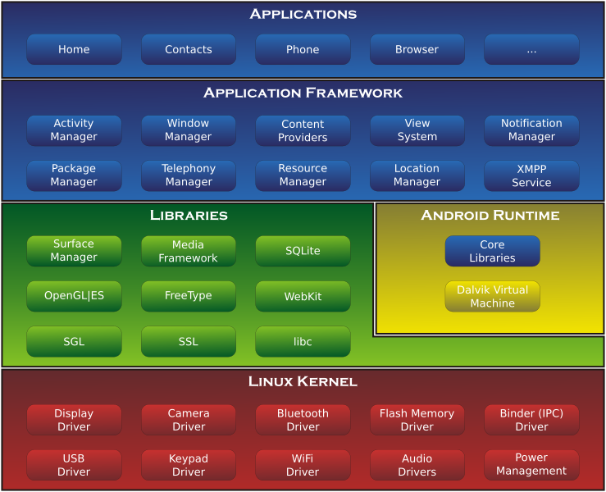

2.1 Linux Kernel

Linux Kernel (Linux 2.6) is at the bottom layer of the software stack. Whole Android Operating System is built on this layer with some changes made by the Google [5]. Like main Operating System it provides the following functionalities: Process management, Memory Management, device management (ex. camera, keypad, display etc.). Android operating system interacts with the hardware of the device with this layer [6]. This layer also contains many important hardware device drivers. Linux kernel is also responsible for managing virtual memory, networking, drivers, and power management [7].

2.2 Native Libraries Layer

On the top of the Linux Kernel layer is Android's native libraries. This layer enables the device to handle different types of data. Data is specific to hardware. All these libraries are written in c or c++ language. These libraries are called through java interface. Some important native libraries are: Surface Manager: it is used to manage display of device. Surface Manager used for composing windows on the screen. SQLite: SQLite is the database used in android for data storage. It is relational database and available to all applications. Web Kit: It is the browser engine used to display HTML content. Media framework: Media framework provides playbacks and recording of various audio, video and picture formats.( for example MP3, AAC, AMR, JPG, MPEG4, H.264, and PNG). Free Type: Bitmap and Font Rendering OpenGL | ES: Used to render 2D or 3D graphics content to the screen : It contains System related C libraries [5].

2.3 Android Runtime

Android Runtime consists of Dalvik Virtual machine and Core Java libraries. It is located on the same level as the library layer [5]. Dalvik Virtual Machine is a type of Java Virtual Machine used for running applications on Android device. The Dalvik VM enables every Android application to run in its own process, with its own instance of the Dalvik virtual machine. The Dalvik VM allows multiple instance of Virtual machine to be created simultaneously providing security, isolation, memory management and threading support [8]. Unlike Java VM which is process-based, Dalvik Virtual Machine is register base. Dalvik Virtual Machine run .deck files which are created from .class file by dx tool. dx tool is included in Android SDK. DVM is optimized for low processing power and low memory environments. DVM is developed by Dan Bornstein from Google [9].

2.4 Application Framework

The Application Framework layer provides many higher-level services or major APIs to applications in the form of Java classes. Application developers are allowed to make use of these services in their applications [6]. These are the blocks with which developer's applications directly interact. Important blocks of Application framework are: Activity Manager: It manages the life cycle of applications. Content Providers: It is used to manage the data sharing between applications, manages how to access data from other applications. Telephony Manager: it manages all voice call related functionalities. Location Manager: It is used for Location management, using GPS or cell tower. Resource Manager: Manage the various types of resources used in Application [8].

2.5 Application Layer

The Applications Layer is the top layer in the Android architecture. Some applications come preinstalled with every device, such as: SMS client app, Dialer, Web browser and Contact manager. A developer can write his own application and can replace it with the existing application [8].

III. DIFFERENT SECURITY FEATURES OF ANDROID OS

Android Operating system should ensure the security of users, user's data, applications, the device, and the network. To achieve the security of these components Android provides these key security features [10]:1) Security at the Operating System level through the Linux kernel. 2) Application sandbox for all applications 3) Secure inter process communication. 4) Application signing.

3.1 Linux Kernel

Android operating system is based on Linux kernel. Due to its open source nature it is researched, attacked and fixed by many research developers. So Linux has become stable and secure k5) Application-defined and user-granted permissions. kernel. Linux kernel provides Android with several key security features including: a) A user-based permissions model In the Linux file system each file and directories has three user based permissions. owner, group, other users. owner - The Owner permissions apply only the owner of the file or directory. group - The group permissions apply only to the group that has been assigned to the file or directory. other users - The other Users permissions apply to all other users on the system. Each file or directory has three basic permission types: read - The read permission means user's ability to read the contents of the file. write - write permissions mean's user's ability to write or edit a file or directory. execute - The execute permission means user's ability to execute a file or view the contents of a directory [11]. This permission model ensures that proper security is maintained while accessing android files. b) Process isolation: The Android operating system assigns a unique user ID (UID) to each Android application and runs it as a separate process. c) Extensible mechanism for secure IPC. d) The ability to remove unnecessary and insecure parts of the kernel [10].

3.2 The Application Sandbox
A sandbox is a security mechanism for separating running programs and limiting the resources of the device to application. It is often used to execute untested code or programs from untrusted users and untrusted websites. By using sandboxing technique limited access to device’s resources is given. Therefore security of the system is increased. Sandboxing technology is frequently used to test unverified programs which may contain a virus or other malware code, without allowing the software or code to harm the host device. With the help of sandbox untrusted program access only those resources of the device for which permission is granted. Permission is denied if it tries to access other resources of the device [12].

3.3 Secure inter-process communication

Some of the applications still use traditional Linux techniques such as network sockets, file system and shared files for inter-process communication. But android operating system also provides new mechanism for IPC such as Binder, Services, Intents and Content Providers. All these mechanism allows developers to verify the identity of application and also used to set the security policies [13].

3.4 Application signing

In order to install and run applications on Android OS they must be digitally signed. With this mechanism Android OS identifying the author of an application. This feature also used to establishing trust relationship between applications. If an application is no signed properly then it cannot be installed on the emulator also. Some standard tools such as Key tool and Jar signer are used to generate keys and sign application .apk files [15]. 3.5 Application-defined and user-granted permissions Permissions are an Android security mechanism to allow or restrict application access. By default, Android applications have no permissions granted, making them safe by not allowing them to gain access to protected APIs [14]. Some of the protected APIs include: Camera functions, Location data (GPS) ,Bluetooth functions, Telephony functions, SMS/MMS functions and Network or data connections. These resources are accessed only through the operating system [10].

From above discussion it is clear that Android Operating System follows a variety of security mechanism. When a developer install an application a new user profile with that application is created. Each application run with its own instance of Dalvik VM. So applications cannot access each other’s data. If applications want to access shared data or resources then they require permissions. All Android applications are signed so users know that the application is authentic. The signing mechanism allows developer to control which applications can grant access to other application on the system.

Conclusion:

Android powers hundreds of millions of mobile devices in more than 190 countries around the world. It's the largest installed base of any mobile platform and growing fast—every day another million users power up their Android devices for the first time and start looking for apps, games, and other digital content. Android gives a world-class platform for creating apps and games for Android gives you everything you need to build best-in-class app experiences. It gives you a single application model that lets you deploy your apps broadly to hundreds of millions of users across a wide range of devices—from phones to tablets and beyond. Android is used by many peoples in the world, a total of 261.1 million smart phones were shipped during this quarter, 81 percent of which run Google's operating system. The next versions of Android have will be more and more powerful and enhanced from the last releases overcome the actual expectations and that the future possibilities became a reality and may this software is also developed to use in PC’s also.

REFERENCES
[1] http://www.engineersgarage.com/articles/wh at-is-android-introduction.
[2] http://en.wikipedia.org/wiki/Android_(operating_system)
[3] http://developer.android.com/about/index.html
[4] http://en.wikipedia.org/wiki/Android_Software development
[5] http://www.tkhts.com/android/android-architecture.jsp
[6] http://www.tutorialspoint.com/android/andro id_architecture.htm
[7] http://www.compiletimeerror.com/2012/12/ blog-post.html#.UuYiIGC6bIU
[8] http://www.android-appmarket.com/ android -architecture.html
[9] http://ptcoresec.eu/2013/05/02/part-1-getting -to-know-android/
[10] http://source.android.com/devices/tech/secur ity/
[11] http://www.linux.com/learn/tutorials/309527 -understanding-Linux-file-permissions
[12] http://en.wikipedia.org/wiki/Sandbox_(computer_security)
[13] http://developer.android.com/training/article s/security-tips.html
[14] http://www.ibm.com/developerworks/library /x-android security/
[15] http://developer.android.com/tools/publishin g/app-signing.html
[16]http://gvpress.com/journals/IJMUE/vol12_no7/3.pdf
[17]https://ieeexplore.ieee.org/abstract/document/6799598

